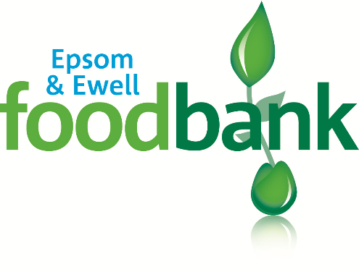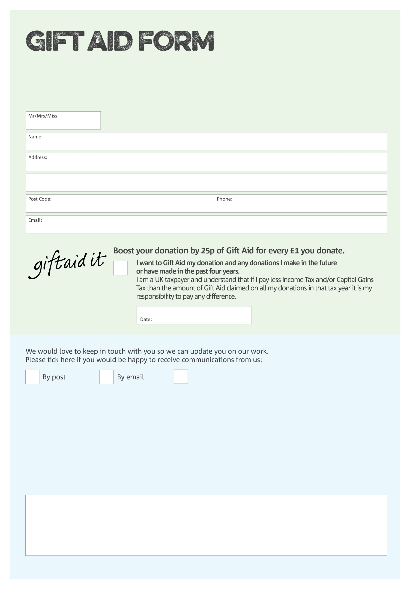ó

By filling in this form Epsom & Ewell Foodbank will receive an extra 25p for every £1 you give at no extra cost to you. Thank you!

**Data protection**

*Epsom & Ewell Foodbank is committed to protecting your privacy and will process your personal data in accordance with current Data Protection legislation. Epsom & Ewell Foodbank collects information to keep in touch with you and supply you with information relating to our work. To unsubscribe from our newsletter, send a message to the email address above with the word unsubscribe in the subject line. A full data privacy statement for financial donors is available from the foodbank on request.’*

You can change your preferences any time by contacting us on 0208 786 8221 or emailing us on

foodbank@generation.org.uk

I do not wish to receive future communications from Epsom & Ewell Foodbank

We would love to know why you have chosen to donate to Epsom & Ewell Foodbank. If you would like to share your motivation let us know below:

Charity Number 1002721. Registered in England and Wales.