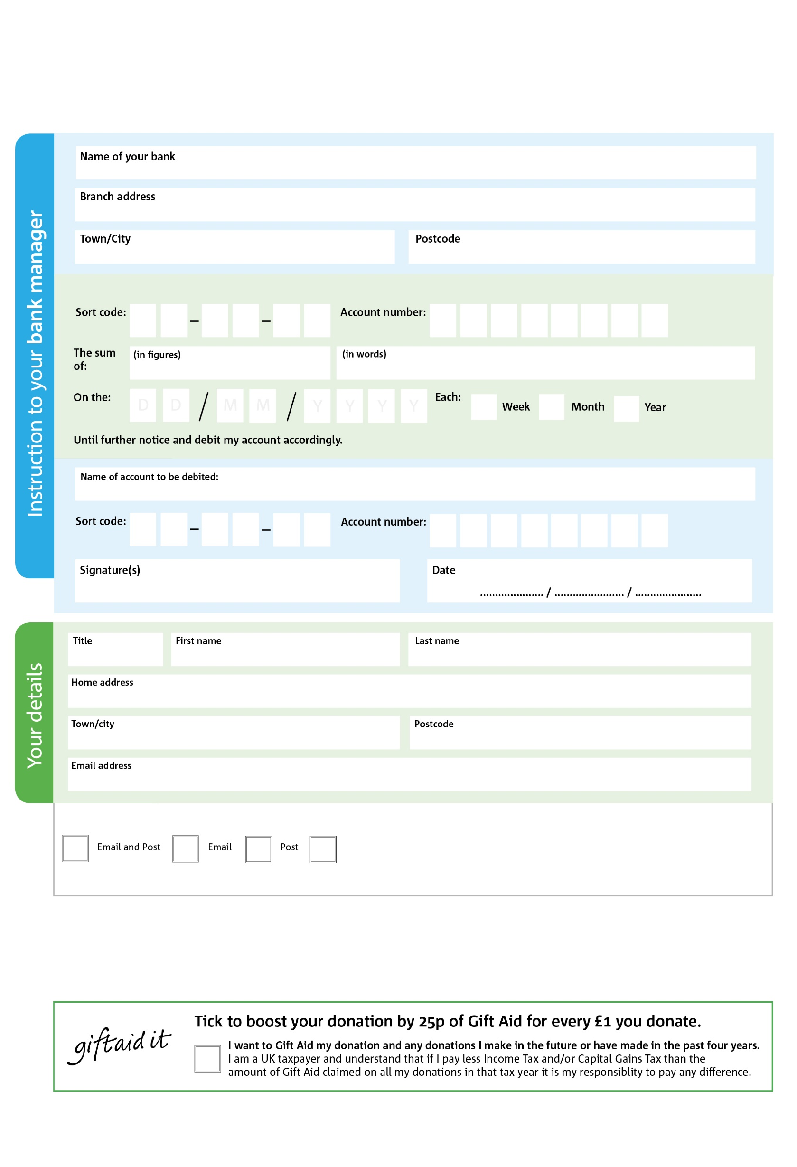

POSTAL ADDRESS: Epsom & Ewell Foodbank, Generation Resource Centre, Ruxley Lane, Ewell, KT19 0JG

6

V

6

V

7

V

8

V

2

V

0

V

0

V

0

V

**Please pass this form on to the foodbank, using the foodbank’s address at the bottom, who will save a copy for their records. They will then send it on to your named bank or building society.**

0

4

2

5

0

4

We would love to keep you up to date with information about Epsom & Ewell Foodbank. Please tick your preference:

You can change your preferences any time by contacting us on 020 8786 8221 or emailing us at foodbank@generation.org.uk

I do not wish to receive future communications from Epsom & Ewell Foodbank

Please pay Epsom & Ewell Foodbank,

**Data protection**

Epsom & Ewell Foodbank is committed to protecting your privacy and will process your personal data in accordance with the Data Protection Act 1998.   
Epsom & Ewell Foodbank collects information to keep in touch with you and supply you with information relating to our work. Epsom & Ewell Foodbank   
will never sell or pass your details to anyone who isn’t directly working on our behalf.

**Standing Order Mandate**

**epsomewell.foodbank.org.uk**

Reg. Charity No: 1002721 | Reg. in England & Wales

You can change your preferences any time by contacting us on XXXXXXXXXXX or emailing us at XXXX@XXXXXXXXXX.foodbank.org.uk

I do not wish to receive future communications from XXXXXX Foodbank